**Sprint 1 Tasks**

*Sprint 1 due March 27th, Required Documents due April 3rd.*

Ask Gesick for the New Customer Template.

Ask Gesick if Required Documents refers to Prototype 1.

* Refer to “Provided by Gesick” folder for Master Product List and New Order Template

**Prototype 1:**

PURPOSE: Explore graphic design of final product implementation and illustrate the flow.

Refer to *Visualization Memo PowerPoint* as our outline/foundation.

* Research effective colors, fonts, alignment, and icons
  + Make informed choices on why we chose ^
* Prototype screens include:
  + scaled images
  + input fields
  + display fields/boxes
  + selection processes (radio buttons/check boxes)
* Fill empty fields with actual data from Master Product List, New Customer Template, and New Order Template

***Roles:***

* Researcher: find and share effective colors, fonts, and icons to be used in PowerPoint prototype
  + NAME:
* Writer: Apply updates to the PowerPoint with new colors, fonts, icons, and aligns
  + NAME:
* Editor: Finalize alignments and design of PowerPoint then include actual data in empty fields
  + NAME:

**Required Documents:**

Refer to t*emplate requirements docs* in D2L.

**Requirements Definition Doc:**

Functional and non-functional requirements must follow “user-story style” with a unique ID.

For example:

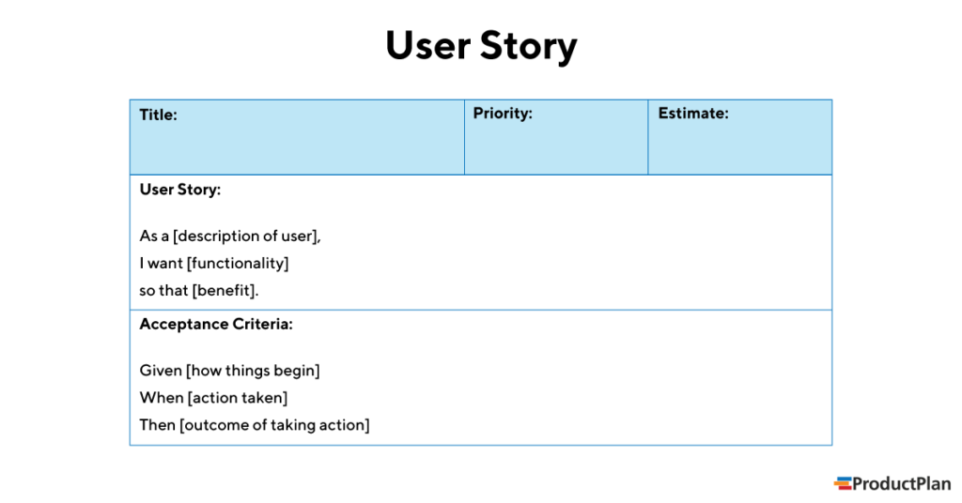

* Functional requirements
  + 1-2 sentences identifying each functional requirement of the system
* Non-functional requirements
  + 1-2 sentences identifying each non-functional requirement of the system

**Requirements Specification Doc:**

* Use Case Diagram
  + Refer to Use-Case/Usage Scenaria in *Technical Description folder*
  + If necessary, show actors and interactions with major functionalities of system
* Use Case Flow of Events
  + Create use case flow of events for EACH main flow from Use Case Diagram^
  + Include preconditions, subflows, and alternate flows
* Class Diagrams
  + UML class diagrams for system
  + Include class name and relationship between classes (inheritance, dependency, association, aggregation, multiplicity)
* Class Documentation
  + 3-4 sentences describing the class and its functions and interactions
* ER Diagram
  + Insert with class design pattern (NOT tables)
  + Show the data and its relationships as it is stored in the database
* Decision Table OR State Transition Diagram
  + Design with set of rules/conditions to support testing of system
  + State Transition Diagram
    - Show significant states of system and events that cause transition from one state to the next

***Roles:***

* Writer:
  + Functional and Non-functional Requirements (Requirements Definition)
    - NAME:
* Diagramer:
  + Use Case
  + Use Case Flow of Events
  + ER
    - NAME:
* Class Diagramer:
  + Class Diagrams UML
    - NAME:
* Class Documenter:
  + Class Documentation
    - NAME:
* Decision Table Diagramer
  + Decision Table OR State Transitions
    - NAME: